Chapter 5: Physical and chemical change

5.1 Physical change is a change in shape or appearance

Student worksheet answers (pages 80–81)

Physical changes

1 What is a physical change?

A change that is reversible

2 Give an example of a physical change and explain why it is a physical change.

Answers may vary.

The melting of ice into water – it is a physical change as water can be frozen back into ice

3 What happens to the molecules in water when they change state from a liquid to a gas?

The molecules move further apart and gain more kinetic energy

4 What happens to the molecules in water when they change state from a gas to a liquid?

The molecules move closer together and lose kinetic energy

5 Explain why boiling water is a physical change.

The boiling of water into steam can be reversed as steam can be condensed into water

6 Match the following words to their meanings.

|  |  |
| --- | --- |
| 1 Vapour | C Gaseous form of a substance |
| 2 Boil | E Occurs when you heat a liquid to become a gas |
| 3 Condense | D When you cool a gas to become a liquid |
| 4 Fumes | F Vapours that are smelly |
| 5 Vaporise | H Liquid evaporates to become a gas |
| 6 Lattice | B Three-dimensional arrangement of particles in a regular pattern |
| 7 Volatile | A Substances that vaporise easily |
| 8 Melting | G When you heat a solid to become a liquid |
| 9 Sublimation | I When you heat a solid and it becomes a gas rather than a liquid |

7 Label the following diagram with the correct terminology to illustrate a change in state of water.

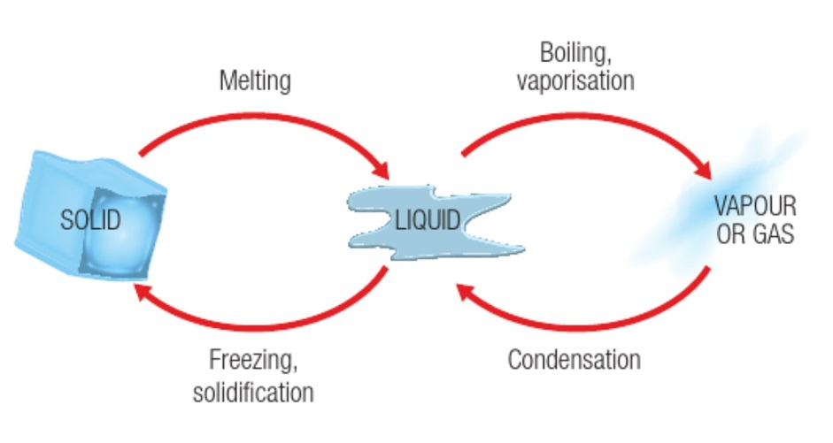

8 Explain the difference between melting and sublimation.

For substances that can exist as liquids, solids melt into liquids. For substances that cannot exist as liquids, solids sublime into gases.

9 Explain the difference between solidification and freezing.

There is no difference – they are the same thing

Extend your understanding

10 Provide four examples of physical changes in your home and explain why each one is considered to be a physical change.

*Answers will vary.* Examples include:

· Boiling of water to cook food – can be reversed back into a liquid via condensation

· Melting of ice in your drink on a hot day – reversible as it can be re-frozen

· Condensation on windows on a cold morning – caused by gases being cooled into liquids, which can be reversed by heating the gas and evaporating it

· Water is frozen into ice cubes in the freezer on a hot day – when they are added to water they will melt back into liquids, cooling down the drink

5.2 Chemical change produces new substances

Student worksheet answers (pages 82–83)

Chemical changes

1 What is a chemical change?

A change that produces a new chemical by rearranging atoms; cannot be reversed

2 Use the following diagram to explain the difference between a chemical and physical change

In a physical change, only the appearance of the substance changes because particles are rearranged. In a chemical change, new chemicals are made.

3 What are four signs that you would look for to know that a chemical change has occurred?

Colour, bubbles, change in temperature, formation of solids

4 Explain why heating chocolate can be both a chemical and physical change.

It can be physical because, if melted properly, it can be solidified back into the chocolate block. It can be chemical because, if heated at a temperature that is too high, it will burn and clump, and you will not be able to use it.

5 What would you look for to know that melted chocolate has undergone a chemical rather than a physical change?

It will clump together and no longer be smooth

6 Explain why each of the following examples are, or could be, chemical changes.

|  |  |
| --- | --- |
|  | A precipitate is formed when two chemicals are mixed together.  The precipitate that forms is a solid that does not go away. |
|  | An iron nail reacts with water and oxygen to form rust.  It is a chemical change as the colour changes. |
|  | Sodium metal and water will react to create light and heat.  The light and heat imply that energy has been released to the surroundings. |
|  | When a tablet is dissolved in water, it generates bubbles.  Bubbly are a sign that a gas has been produced – a chemical reaction. |
|  | If heated at a temperature that is too high, chocolate will burn and clump together.  This is irreversible as, once it is burnt, the chocolate cannot be melted. |

Extend your understanding

7 Are the following pictures examples of chemical or physical changes?

|  |  |  |  |
| --- | --- | --- | --- |
| physical | chemical | chemical | physical |
| chemical | chemical | physical | chemical |

5.3 Chemical reactions can break bonds and re-form new bonds

Student worksheet answers (pages 84–85)

Chemical reactions

1 What is a chemical reactant?

A substance used at the beginning of a chemical reaction

2 What is a chemical product?

A substance formed/produced at the end of a chemical reaction

3 On which side of a chemical reaction arrow do products and reactants belong?

Reactants on the left; products on the right

4 Write a worded chemical equation for the following chemical reactions, and label the reactants and products (using the second line).

a Oxygen and hydrogen react to form water

hydrogen + oxygen → water

reactants → products

b Iron and oxygen will form iron oxide

iron + oxygen → iron oxide

reactants → products

c Peroxide will break down (decompose) into water and oxygen

peroxide → water + oxygen

reactants → products

d Water and carbon dioxide react in the leaves of plants to form glucose (a sugar) and oxygen

water + carbon dioxide → glucose + oxygen

reactants → products

e Petrol, in a car, will burn in the presence of oxygen to form carbon dioxide and water

petrol + oxygen → carbon dioxide + water

reactants → products

5 What is a combustion reaction?

A reaction with oxygen to produce energy

6 Write a worded equation for the combustion of magnesium.

magnesium + oxygen → magnesium oxide (+ energy as light)

7 The products of the combustion of hydrocarbons are carbon dioxide and water. Write worded equations for the following reactions and label the reactants and the products (using the second line).

a combustion of ethene

ethene + oxygen → carbon dioxide + water

reactants → products

b combustion of octane

octane + oxygen → carbon dioxide + water

reactants → products

Extend your understanding

Polymerisation is the process of joining many small molecules (monomers) together to make one very large molecule (polymer). Plant cell walls, for example, are made out of cellulose. Cellulose is a large polymer made up of many glucose monomers. This polymerisation process is called condensation polymerisation.

8 What does the suffix ‘mono’ mean in the word ‘monomer’?

‘Mono’ means *one*, so monomer means one molecule

9 What does the suffix ‘poly’ mean in the word ‘polymer’?

‘Poly’ means *many* or *more than one*, so polymer means more than one molecule

10 Research and draw the structure of glucose, showing all the bonds between atoms.

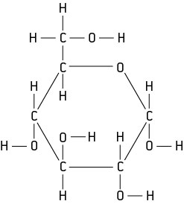

11 What does condensation mean?

That liquid water has been produced

12 What would be the products of a condensation polymerisation reaction?

A polymer and liquid water

5.4 Heat can speed up a reaction

Student worksheet answers (pages 86–87)

The effect of heat on the speed of reactions

1 How does particle size affect the rate of a chemical reaction?

The smaller the particles, the faster the rate of reaction because smaller particles have a larger surface area

2 Which of the following diagrams will have a faster rate of reaction? Explain your answer.

Diagram a, as smaller particles with a larger surface area will have a faster rate of reaction

3 What must happen in order for chemicals to react? (Hint: collision theory)

For substances to react, their particles must come into contact with each other or collide. The more collisions that happen between the particles, the more likely they are to react.

4 How does temperature increase the rate of a reaction?

Heat energy is added to the substance, so the particles move quicker and collide more frequently

5 What type of energy does temperature give to particles?

Kinetic energy

6 What is the definition of this type of energy?

It is the energy of movement

7 What is concentration?

It is the amount of a substance in a set volume; more particles = higher concentration

8 How does concentration affect the rate of a reaction?

A more concentrated substance has more particles available to collide with particles from another substance.

9 Which of the following diagrams will have a faster rate of reaction? Explain your answer.

Diagram b, as it is more concentrated with more particles that will collide more often

10 What is a catalyst?

It is a substance that increases the rate of a reaction without becoming used up by it

11 How does a catalyst affect the rate of a chemical reaction?

It increases the rate of reaction (makes it faster).

12 Why are enzymes ‘fussy’?

They only work with one type of reactant and so will only catalyse one reaction each

Extend your understanding

13 Travis and Jack perform two chemical reactions under different conditions. Travis wants to react different concentrations of hydrochloric acid with magnesium metal. Jack wants to see whether increasing the temperature of a reaction will make it go faster. The reactions they used are shown below.

|  |  |  |  |  |
| --- | --- | --- | --- | --- |
| Jack | |  | Travis | |
| Beaker 1 | Beaker 2 |  | Beaker 1 | Beaker 2 |
| Dilute hydrochloric acid + 1 g of magnesium ribbon  at 20ºC | Concentrated hydrochloric acid +  1 g of magnesium ribbon at 20º C |  | Concentrated hydrochloric acid +  1 g of magnesium ribbon at 20º C | Concentrated hydrochloric acid +  1 g of magnesium ribbon at 60º C |

a What is Jack’s hypothesis?

That increasing concentration will increase the rate of a reaction

b What is Travis’s hypothesis?

That increasing temperature will increase the rate of a reaction

c What will be Jack’s results? Explain why.

Beaker 2 will react faster. It has a higher concentration and more particles, and therefore will have more collisions.

d What will be Travis’ results? Explain why.

Beaker 2 will react faster. It has a higher temperature, more energy and more movement, and therefore will have more collisions.

5.5 Science as a human endeavour: Many substances exist because of the work of scientists

Student worksheet answers (pages 88–89)

Chemical substances

1 What is the role of a chemist in a pharmacy?

To prepare and dispense medication

2 What is a chemist who works in a pharmacy called?

A pharmacist

3 Explain the process of oil being extracted from the ground and turned into petroleum.

Oil is pumped from the ground and is carried in pipelines or tankers to refineries, where it is separated into its components. The low-value parts of the crude oil mixture are converted into high-value products, such as petroleum.

4 What high-value materials is crude oil converted into?

Petroleum, diesel, plastics

5 What can plastics be used for?

Answers may vary. Examples include freezer bags, CD cases, shoes, furniture and clothing.

6 When and where was the first documented case of glue?

In ancient Babylon 3500 years ago, used by King Nebuchadnezzar

7 What was glue first used for?

Used in the form of bitumen to hold building stones together

8 From what sources can glues be extracted?

Plant gum, egg whites, and animal products such as gelatin

9 What is the difference between natural and synthetic glue?

Natural glue is made from biological material; synthetic glue is made from the products of oil

10 What was the first dye obtained from?

The shells of murex whelks, a type of snail

11 How was the colour purple or ‘mauve’ discovered? Who discovered it and when did they do so?

In 1978, William Perkin discovered the first synthetic dye (mauve) by accident

12 What is an advantage of modern inks over earlier ones?

They do not fade and are therefore able to last longer

Extend your understanding

There are many different types of chemists who perform many different analyses on materials for many different purposes. Match the following chemical areas to the analyses that they perform.

|  |  |  |  |  |  |  |
| --- | --- | --- | --- | --- | --- | --- |
| *Organic chemistry* | *Analytical chemistry* | *Industrial chemistry* | *Food chemistry* | *Environmental chemistry* | *Forensic chemistry* | *Pharmaceutical chemistry* |

13 What kind of chemistry is required to:

a perform DNA analysis?

Forensic chemistry

b create pharmaceutical drugs?

Pharmaceutical chemistry

c work in a mining smelter?

Industrial chemistry

d determine the chemical makeup of unknown chemical samples?

Analytical chemistry

e extract biomolecules from seaweed and determine their function?

Organic chemistry

f analyse smog to determine its impact on the environment?

Environmental chemistry

g taste test ice-cream to ensure it has the correct composition of flavours?

Food chemistry

5.6 Science as a human endeavour: Physical and chemical changes are used to recycle household waste

Student worksheet answers (pages 90–91)

Recycling

1 How many groups are plastics classified into?

Seven main groups

2 The steps below for the mechanical/physical recycling of plastics are out of order. Write the correct number next to its corresponding description.

|  |  |
| --- | --- |
| Step Number | Description of the process |
| 4 | Floating off the plastics according to their density |
| 6 | Cooling the strands and cutting it into small pellets so that it can be reused for new products |
| 5 | Extruding the plastic by heating it to a melting state and forcing it into long strands |
| 1 | Cutting the large pieces of plastic using shears or saws |
| 3 | Separating the contaminants in cyclone (centrifuge) separators |
| 2 | Shredding the plastic into small flakes |

3 What does the chemical recycling of plastics involve?

Breaking long polymer molecules up into small monomer molecules

4 How can metals be recycled?

By melting and reshaping them

5 What is corrosion? Give an example with a worded chemical equation.

A reaction between a metal and air to produce a different chemical

Example: iron + oxygen ® rust (iron oxide)

6 Why is corrosion a problem in recycling?

The reaction is difficult to reverse – iron oxide cannot be turned back to iron to be melted as it is a chemical change, not a physical change

7 Match each of the plastics symbols below with the correct description.

|  |  |  |
| --- | --- | --- |
| SYMBOL |  | DESCRIPTION |
|  |  | C Polyethylene terephthalate (PET or PETE) is the plastic found in soft drink bottles or oven ready meal trays |
|  |  | F High density polyethylene (HDPE) is used to make milk and juice bottles, some washing-up bottles, toys and grocery bags |
|  |  | A Polyvinyl chloride (PVC) is used to make clear food packaging, shampoo and medication bottles, and food trays |
|  |  | G Low density polyethylene (LDPE) is used to make grocery bags, bin liners, bread bags and frozen food bags |
|  |  | B Polypropylene (PP) is used to make microwave meal trays, sauce bottles, yoghurt containers and medicine bottles |
|  |  | E Polystyrene (PS) is used to make foam meat or fish trays, coffee cups, plastic cutlery and sandwich boxes |
|  |  | D Contains all other plastics, including nylon and fibreglass that cannot be recycled |

Extend your understanding

8 Which of the plastics in question 7 can be recycled by your curbside rubbish collection? Which cannot?

In most areas, plastics in groups 1, 2 and 3 can be recycled, but 4–7 cannot. Councils are developing way to recycle 4–7.

9 Many people do not understand which plastics are which, how to tell the difference, or which ones can be recycled. Create a mini-poster in the space below to educate them.

*Answers will vary.* The poster should include symbols 1–7 for the different groups of plastics, the types of plastics each group are, whether or not they can be recycled, and how to recognise each type of plastic.